**MYZONE** is a new innovative heart rate based system that uses wireless and cloud technology to accurately and conveniently monitor physical activity. It monitors heart rate, calories and time exercising that converts into **MYZONE** Effort Points (MEPs), with a focus on rewarding effort rather than fitness

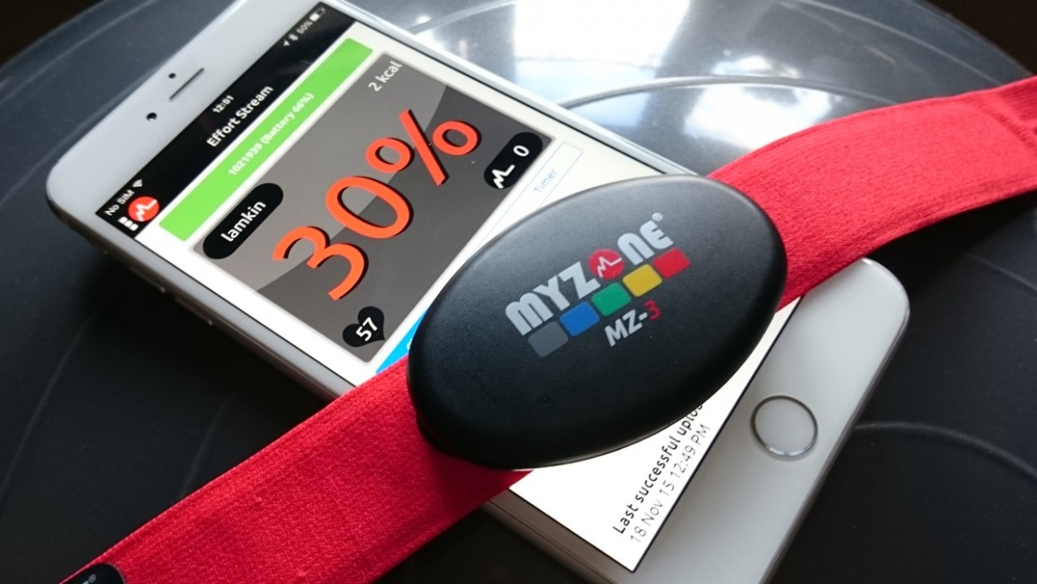.

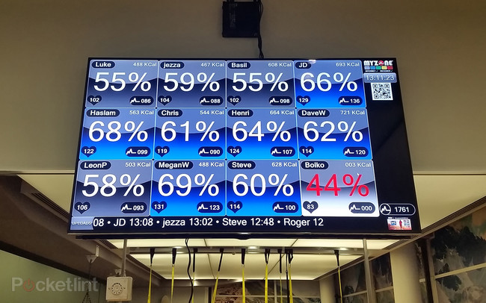

**Heart rate zones tell all**

The MyZone MZ-3 tracker is a chest worn heart rate belt. Unlike older uncomfortable ones this uses a seamless soft plastic on the skin side of the band so you barely notice it's on after a while. This intelligently connects to the phone app via Bluetooth the moment it's clipped on and starts tracking. Simple.

The MZ-3 is water resistant to 10 metres, comes in three sizes, lasts seven months on a charge and has 16 hours of storage direct on the unit, in case you want to record without a phone. The unit also has ANT+ and analogue transmission so it can technically work with most devices.

The MyZone makers are keen to point out that chest worn monitoring is still far more accurate that optical wrist worn attempts at tracking. Since MyZone is based on very specific heart rate zone training this accuracy is highly important.

In a gym-based situation, like we were in, the data from our strap was shown on a large screen at the front of the room. It's also shown on the phone app, live, so can work anywhere. This reads out heart rate and a percentage of max number. This is the measure of total effort you personally can put it. This is based on metrics like age, height, weight, sex, resting heart rate and max heart rate.

When in a workout you can setup zones you need to be in to achieve the results you're going for. Or follow a workout setup already, by a trainer for example. The screen changes colour as the zones change. If you're at the right heart rate your tile, which shows your heart rate percentage, will change to match the correct zone. The longer you're in the zone during that time the more points you accrue – these are called MEPs, or MyZone Effort Points. The higher the heart rate percentage zone, the more points you receive. So the ultimate goal is to stay in the zone and aim for more intense zones for longer.

The grey zone, for 50-59 per cent of max heart rate, earns you 1MEP per minute, the blue zone, for 60-61 per cent awards 2 MEPs, green for 70-79 per cent earns you 3 MEPs per minute and the yellow zone for 80-89 per cent and red zone for 90-100 per cent give 4 MEPs per minute. Red zone training too much can be damaging hence the top two being on a par.

It has to be said that for people looking to burn fat research suggests lower heart rate bands can help more than higher. But for overall fitness pushing the upper limits can help.

Since all this is tailored to you personally it creates a level playing field. In our class we chose to ride the bike as it was an easy way to control heart rate. While we were sweating at one stage the person next to us was fine – even though we were in the same heart rate zone.